8.109: a) Noting than 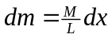 avoids the intermediate variable. Then,

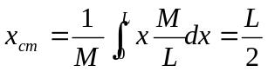.

b) In this case, the mass M may be found in terms of and L, specifically by using 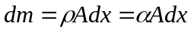 to find that 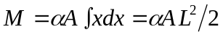. Then,

